1. Stream
Definition: Stream is an abstract base class that provides a generic view of a sequence of bytes, serving as the foundation for all stream-based classes in C#.
Purpose: Defines common methods and properties (e.g., Read, Write, Seek, Flush, Close) for working with streams, which could represent files, network data, or memory buffers.
Key Characteristics:Abstract, so it cannot be instantiated directly.
Supports both synchronous and asynchronous operations.
Provides a unified interface for derived classes like FileStream, MemoryStream, etc.
Use Case: Used as a base for polymorphism or when writing generic code that can work with any stream type.

2. MemoryStream
Definition: A stream that uses memory as its backing store, allowing reading and writing of data in memory rather than to a physical device like a file or network.
Purpose: Ideal for temporary storage or manipulation of data in memory before writing to another destination or processing.
Key Characteristics:Data is stored in a resizable byte array in memory.
No disk I/O, so it’s fast but limited by available memory.
Supports seeking (random access to any position in the stream).
Can be converted to a byte array using ToArray() or written to another stream.
Use Case: Temporary data storage, serialization, or when you need to work with data in memory before saving to a file or sending over a network.

3. BufferedStream
Definition: A stream that adds buffering to another stream (e.g., FileStream or NetworkStream) to reduce direct access to the underlying resource, improving performance.
Purpose: Enhances performance by minimizing calls to the underlying system (e.g., disk or network) through an internal buffer.
Key Characteristics: Wraps another Stream object; does not directly interact with data sources.
Reduces overhead by reading/writing larger chunks of data at once.
Configurable buffer size (default is 4096 bytes).
Best for scenarios with frequent small reads/writes.
Use Case: Wrapping a FileStream or NetworkStream to improve performance for small, frequent I/O operations.

4. StreamReader
Definition: A class for reading text (characters) from a stream, typically with a specified encoding (e.g., UTF-8).
Purpose: Simplifies reading text data, such as lines or entire contents of a file or stream.
Key Characteristics:Reads characters, not raw bytes, using an encoding to interpret the byte stream.
Built on top of a Stream (e.g., FileStream or MemoryStream).
Provides methods like ReadLine(), ReadToEnd(), and ReadAsync().
Does not support writing.
Use Case: Reading text files, such as configuration files, logs, or CSV files.

5. StreamWriterDefinition: A class for writing text (characters) to a stream, typically with a specified encoding.
Purpose: Simplifies writing text data to a stream or file.
Key Characteristics:Writes characters, converting them to bytes using an encoding (e.g., UTF-8).
Built on top of a Stream.
Provides methods like Write(), WriteLine(), and WriteAsync().
Automatically flushes data when disposed or when AutoFlush is enabled.
Does not support reading.
Use Case: Writing text to files, such as logs, reports, or configuration files.

6. FileStreamDefinition: A stream that provides access to a file on disk, supporting both reading and writing of raw bytes.
Purpose: Direct low-level access to files for reading and writing binary or text data.
Key Characteristics:Interacts directly with the file system.
Supports seeking, allowing random access to file contents.
Configurable for read-only, write-only, or read-write access.
Can be slow for small, frequent I/O operations unless wrapped with BufferedStream.
Use Case: Reading/writing binary files (e.g., images, serialized objects) or when low-level file control is needed.

Comparison of ClassesFeature/Class
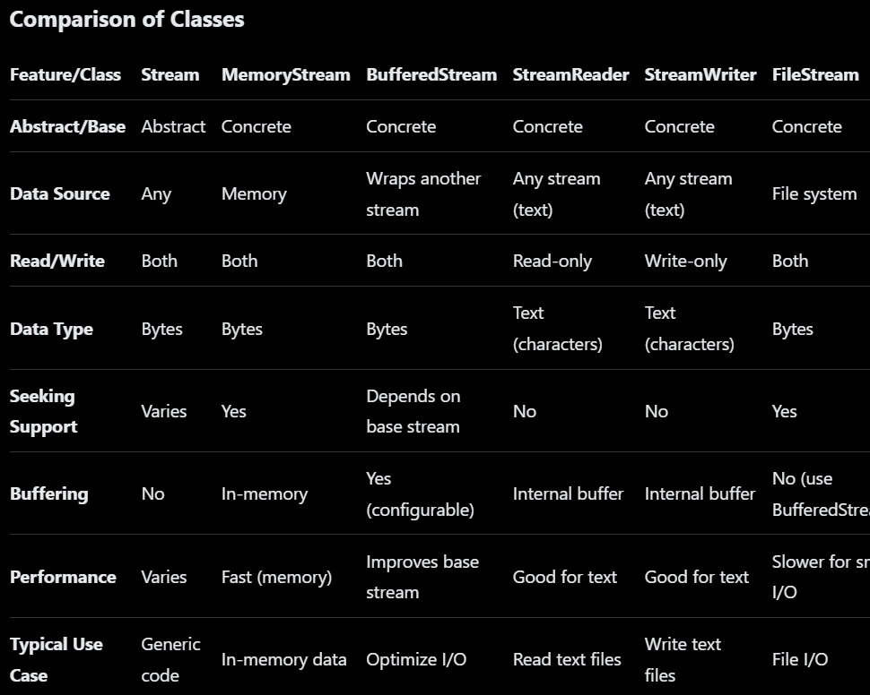
Detailed Comparison and When to Use EachAbstraction Level:Stream is the most abstract, used for generic stream handling or when you need to write code that works with any stream type.
FileStream, MemoryStream, and BufferedStream are lower-level, dealing with bytes.
StreamReader and StreamWriter are higher-level, designed for text.
Performance:MemoryStream is fastest since it operates in memory, but it’s limited by RAM.
BufferedStream improves performance for streams with frequent small reads/writes (e.g., wrapping FileStream).
FileStream can be slower for small I/O operations due to direct disk access; use BufferedStream to mitigate this.
StreamReader and StreamWriter are optimized for text but less efficient for binary data.
Text vs. Binary:Use StreamReader/StreamWriter for text data (e.g., CSV, logs) to handle encoding automatically.
Use FileStream or MemoryStream for binary data (e.g., images, serialized objects).
Flexibility:FileStream offers the most control over file operations (e.g., file access modes, sharing, and seeking).
MemoryStream is flexible for in-memory data manipulation.
BufferedStream is a performance enhancer, not a standalone stream.
StreamReader/StreamWriter are specialized for text and less flexible for binary data.
Typical Scenarios:Reading a text file line by line: Use StreamReader with a FileStream or directly via File.OpenText().
Writing logs to a file: Use StreamWriter for simplicity.
Reading/writing binary files: Use FileStream for direct access or FileStream with BufferedStream for better performance.
Temporary in-memory data: Use MemoryStream for fast, in-memory byte manipulation.
Optimizing file I/O: Wrap FileStream with BufferedStream for frequent small operations.

